

Deliverable Report: <<version>>, issue date on << date >>

Deliverable Report: 2.0, issue date on 10.01.2023

BIM-SPEED

Harmonised Building Information Speedway for Energy-Efficient Renovation

This research project has received funding from the European Union’s Programme H2020-NMBP-EEB-2018 under Grant Agreement no 820553.

**Disclaimer**

The contents of this report reflect only the author’s view and the Agency and the Commission are not responsible for any use that may be made of the information it contains.

A set of BIM Passports of the existing building stock

Deliverable Report: D2.5

A set of BIM Passports of the existing building stock

Deliverable 2.5

Issue Date 10.01.2023

Produced by Planen Bauen 4.0

Main author Essam Fadel

Co-authors Bogdan Tofan

Version: 1.0

Reviewed by Samaneh Rezvani

Approved by Timo Hartmann

Dissemination <<…>>

Colophon

Copyright © 2019 by BIM-SPEED consortium

Use of any knowledge, information or data contained in this document shall be at the user's sole risk. Neither the BIM-SPEED Consortium nor any of its members, their officers, employees or agents shall be liable or responsible, in negligence or otherwise, for any loss, damage or expense whatever sustained by any person as a result of the use, in any manner or form, of any knowledge, information or data contained in this document, or due to any inaccuracy, omission or error therein contained. If you notice information in this publication that you believe should be corrected or updated, please get in contact with the project coordinator.

The authors intended not to use any copyrighted material for the publication or, if not possible, to indicate the copyright of the respective object. The copyright for any material created by the authors is reserved. Any duplication or use of objects such as diagrams, sounds or texts in other electronic or printed publications is not permitted without the author's agreement.

This research project has received funding from the European Union’s Programme H2020-NMBP-EEB-2018 under Grant Agreement no 820553.



Change log

|  |  |  |
| --- | --- | --- |
| Description | Author | Date |
| Initial version 1.0 for internal review | Bogdan Tofan | 29.09.2022 |
| Addressed internal review comments | Essam Fadel | 09.10.2022 |
| Initial version 2.0 for internal review | Essam Fadel | 10.01.2023 |
| Addressed internal review comments | Essam Fadel | 17.01.2023 |
| Finale editorial review | XX | XX |

Publishable executive summary

The Building Information Modeling (BIM) Passport is a comprehensive tool for managing and improving buildings. The BIM Passport helps to improve buildings by providing a comprehensive assessments of BIM Information. By identifying areas for improvement, the BIM Passport can provide recommendations for increasing the efficiency and quality of BIM projects. This can lead to improved building design, construction, and management, resulting in better coordination and collaboration among stakeholders. Ultimately, the BIM Passport can help organizations to make better decisions, improve building performance, reduce costs and increase productivity, by using BIM more effectively.

The deliverable BIM Passport report presented in this document includes evaluations of the building's organizational maturity, compliance with BIM modelling guidelines and standards, and compliance with relevant ontologies specifications. The evaluations were based on a set of criteria and scores were assigned for each criterion. The scores were then used to determine the overall maturity level, compliance level, and compliance with relevant ontologies specifications of the building passport.

The report includes graphical visualizations to provide a clear and easy-to-understand representation of the evaluation results. The visualizations include spider charts, box and whiskers diagrams, and line diagrams. These diagrams provide a clear representation of the scores for each criterion and allow stakeholders to easily compare the scores and identify areas where improvement is needed.

Based on the evaluation scores, certifications were issued for the building passport. These certifications provide assurance of the building passport's quality and compliance with relevant standards and regulations. The certifications include the overall score and scores for each criterion and are provided in both digital and physical form. They can be accessed online and verified by relevant authorities and stakeholders.

The report also includes recommendations for future improvements and an action plan for implementing these recommendations. By implementing the recommendations and taking the necessary actions, building owners, managers, and other stakeholders can improve the building's performance and compliance with relevant standards and regulations.

Overall, the deliverable BIM Passport report provides a comprehensive and actionable plan for improving the building and its processes. The BIM Passport is an important tool for building management, compliance, and improvement and is expected to be continuously updated, improved, and expanded in the future.

It's important to note that the type of this deliverable, the BIM Passport, is "other" and it is a short manual with some background information about the Excel tool that was created to assess the organization's level of BIM maturity. This tool is based on the maturity evaluation, BIM modelling guidelines, and ontologies specifications. The BIM Passport is designed to help the organization identify areas for improvement and provide recommendations for increasing the efficiency and quality of BIM projects.

List of acronyms and abbreviations

BIM: Building Information Model

BEM: Building Energy Model

BEP: BIM Execution Plan

EeB: Energy-efficient Building

EPCB: Energy performance certificate building

HVAC: Heating Ventilation Air Conditioning

IEQ: Indoor Environment Quality

LCA: Life Cycle Analysis

LCC: Life Cycle Costing

MEP: Mechanical Electrical Plumbing

Contents

1. Integrating BIM Passport in the overall construction process 11

1.1 Woningpas 13

1.2 Individual renovation schedule (iSFP - Individueller Sanierungfahrplan) 14

1.3 Energy efficiency passport (Passeport efficacité énergétique –P2E) 15

1.4 BIM SPEED BIM Passport 15

2. BIM Speed passport 17

2.1 Purpose of the report 17

2.2 Overview of the deliverable BIM Passport 17

2.3 BIM Passport Prototype v1.0 17

2.4 Description of the Building Passport v2.0 17

3. Maturity Evaluation 19

3.1 Description of the maturity evaluation process 19

3.1.1 Policies 19

3.1.2 People 19

3.1.3 Processes 19

3.1.4 Technology 19

3.2 Results of the maturity evaluation 20

3.3 BIM Maturity Questionnaire 20

3.4 Maturity Future Recommendations 20

Policies 20

People 21

Processes 21

Technology 21

3.5 Graphical visualization of the maturity level 21

4. BIM Guidelines Evaluation 22

4.1 Description of the BIM guidelines evaluation process 22

4.2 Results of the BIM guidelines evaluation 22

4.3 BIM Modeling Guidelines Questionnaire 22

4.4 Graphical visualization of the BIM guidelines compliance 23

5. Ontologies Evaluation 24

5.1 Description of the ontology’s evaluation process 24

5.1.1 Reno-Inst 24

5.1.2 LCA-C 24

5.1.3 BEM-Reno 24

5.2 Results of the ontologies evaluation 24

5.3 Ontologies Questionnaire 25

5.3.1 Reno-Inst Ontology 25

5.3.2 LCA/C Ontology 25

5.3.3 BEM-Reno Ontology 26

Energy KPIs 26

Sustainability KPIs 26

5.4 Certification visualization of the ontologies compliance 26

6. Building Passport Summary 28

6.1 Summary of all the evaluation results 28

7. Conclusion 29

7.1 Summary of the report 29

7.2 Recommendations for future improvements 29

8. References 30

8.1 List of sources used in the report 30

9. Appendices 31

9.1 Any additional material relevant to the report such as questionnaires, data and screenshots 31

Maturity Questionnaire 31

BIM Modeling Guidelines Questionnaire 33

Reno-Inst Ontologies Questionnaire 34

LCA/C Ontologies Questionnaire 35

BEM-Reno Ontologies Questionnaire 36

Maturity Spider-Chart 37

BIM Modeling Guidelines Box & Whiskers Diagram overlaped with Line Diagram 38

Ontologies Certifications 39

BIM Passport Main Page 40

List of Figures

Figure 1 Residential building age groups per EU country 11

Figure 2 Woningpas energy page 14

Figure 3 iSFP Individual renovation schedule 15

Figure 4 Energy efficiency passport (Passeport efficacité énergétique –P2E) Dashboard 16

Figure 5 Connection between BIM Passport and other Work Packages 17

Figure 6 BIM SPEED - BIM Passport v1.0 Dashboard 19

Figure 7 BIM SPEED - BIM Passport v1.0 Cover Page State, Back Page State, & Full Passport State 19

Figure 8 BIM SPEED - BIM Passport v2.0 Main Page 21

Figure 9 Maturity Tool Evaluation Result (Spider-Chart) 25

Figure 10 BIM Modeling Guidelines Evaluations Result (Box & Whiskers Diagram - overlapped with Line Diagram) 28

Figure 11 Ontologies Evaluation Result as Certificates 32

List of tables

Table 1 Building passports from different entities (Marta Maria Sesana, 2018) 12

List of Appendices

Appendix 1 Maturity Questionnaire

Appendix 2 BIM Modeling Guidelines Questionnaire

Appendix 3 Reno-Inst Ontologies Questionnaire

Appendix 4 LCA/C Ontologies Questionnaire

Appendix 5 BEM-Reno Ontologies Questionnaire

Appendix 6 Maturity Spider-Chart

Appendix 7 BIM Modeling Guidelines Box & Whiskers Diagram overlapped with Line Diagram

Appendix 8 Ontologies Certifications

Appendix 9 BIM Passport Main Page

# Integrating BIM Passport in the overall construction process

Building sector is always in the spotlight of being one of the most important and, at the same time, with the highest energy consumption sector. Estimates are placing energy consumption of buildings from Europe at around 43% from the total consumption of energy and residential buildings account for around two thirds of this (Evolution of households energy consumption patterns across the EU, 2021). Percentage of residential buildings varies from one country to another but varies from 60-85% from total floor area of building constructed. If we think about the age of the buildings, a large percentage from the total stock have more than 20 years, as it can be seen from Figure 1. (Comission, n.d.)

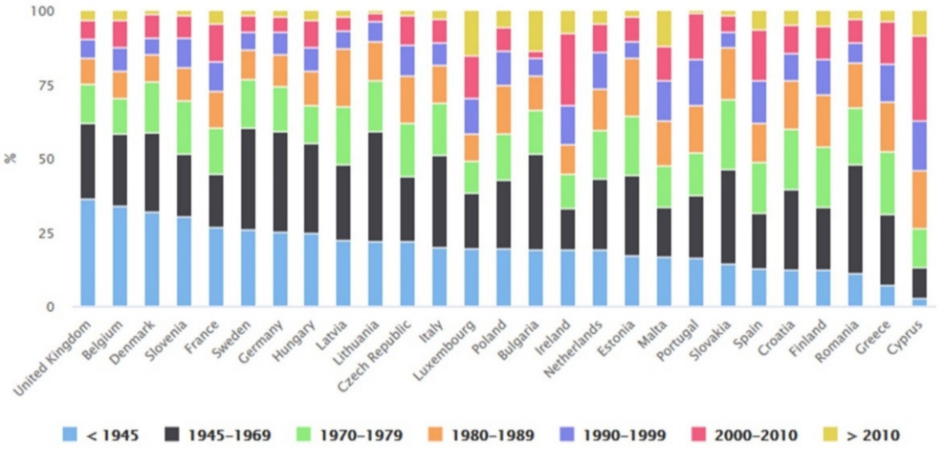

Figure 1 Residential building age groups per EU country

Considering the life cycle of an asset, a residential building “produces” data in every stage of its life-cycle. But no matter the time it has been constructed; the types of data available from a building can be in different formats. In addition, they can be stored using different technologies available in a specific period of their utilization. In modern times building owners have started to understand the value of data and the necessity to have the relevant information for their assets. Unfortunately, since most buildings were already constructed 20-50 years ago or even more, sometimes, acquiring all the data for a building can be a costly process without having a clear goal for what that data is collected and what type is required.

At a European level, there are a few initiatives for building certificates or passports. One of the most known is the Energy Performance Certificate, which was introduce by the European Parliament with the Directive 2010/31 (and further amendments). The EPCB includes the current energy performance of a building and a reference value for comparison. The certificate is addressed towards owners or tenants of the building. The EPCB considers only the data relevant for the determining the energy performance, but the quality and quantity of the data is not mentioned. (European Parliament , 2010)

Other initiatives in developing or proposing building passports were taken by different entities, that can be seen in Table 1.

Table 1 Building passports from different entities (Marta Maria Sesana, 2018)

|  |  |  |  |
| --- | --- | --- | --- |
| Country | Entity | Building passport name | Short description |
| Germany | DEKRA, 2000 | ImmoPass | Mainly aimed at new and existing building in terms of sustainability issues. It is designed as a checklist for sustainable building qualities. |
| Germany | Bundesministeriums für Verkehr,Bau und Wohnungswesen  (BMBBW) | Gëbaudepass | It is describing the main characteristics of a property; energy performance, environmental and health of the building. |
| Germany | European Construction Sector Observatory - Policy measure fact sheet Germany | Hausakte | It was aimed towards single family homes, had comprised of 6 modules: characteristics; description; address; summary tables; drawings, calculations, photos; documents and contracts. It was kept until 2012 but the outcomes of the initiative were largely debatable. |
| Finland | Finnish Green Building Council | Building Passport | Building passport is an accessible, visual tool that presents the key indicators in environmental efficiency, along  with images and the basic facts of the property. The key indicators measured by the building  Performance Indicators can easily be presented in the BP, either for the pre-design or occupancy  phases. |
| Netherlands | Dutch Consultation Platform  Building Legislation (OPB) | Concept of  Building File  (CoBF) | The document should describe the state of the building and its health and comprises of general information, structural state of the building, degree of functionality of the installation and maintenance guide. Targeted group: homeowners/buyers. |
| Netherlands | Ministry of Internal  Affairs | As-Built File  (Oplever-  dossier) | The initiative consists of a dossier of information on the residential building that highlight technical information as well as maintenance information. Supposed to be implemented in 2018. |
| Spain | Ministerio de Fomento | Libro del  Edificio | The booklet is made for each building and contains the reception certificate and instructions for maintenance. The booklet is mandatory since 1999. |
| Italy | Consiglio Nazionale dei Periti Industriali e dei Periti Industriali Laureati | Fascicolo del  fabbricato | It gathers, in a single document, all the distinctive elements of a house. It is a voluntary document. |
| England and Wales | Home Information Pack, Office of the Deputy Prime Minister, Creating sustainable communities | Home  information  pack (HIP) | A set of documents that a seller most provide to the buyer of a building that includes: an Energy performance certificate, owner documents, guarantees. It became mandatory in 2007. |
| Cornwall (UK) | Cornwall Council, Environment Directorate | Building  Logbook | It is intended to summarize any documents that record how the building behaves and it is maintain. |
| UK | CIBSE Building logbook tool kit | Building  Logbook | The documents provide information on how the building is behaving including documents regarding energy performance and major alterations. |
| Romania | Ministery of Public Works | Construction book | Contains the technical documentation of the building and indications to how the building should be maintained and operate. |

The building passports, mentioned in Table 1, highlights different attempts of gathering information of the building for the main purpose of selling/renting in order for the buyer to have a view on how the building behaved, what intervention were made and what is the energy efficiency of it.

As it can be seen, these building passports do not concentrate on the renovation process, although information from them can be used to start defining a renovation concept for a building (e.g., the building passports that contain EPCs). The information needed to define a renovation process for a building requires a lot more information than the solution mentioned prior. The Directive 2018/844 of the European Parliament that introduces the notion of a renovation passport for building, complementary to the EPC, to further support the renovation process and reaching the targets set for 2030 regarding the energy objectives set. In Europe, some initiatives are already in place at a national (Germany, France) or regional level (Flanders, Belgium).

## Woningpas

Woningenpas in Flanders, Figure 2, Belgium was developed based on a collaboration between the Flemish Energy and Climate Agency, the Department of environment, Housing Flanders and the Public Waste Agency of Flanders (OVAM). It is addressed to single or multiple family homes and contains information about insulation, energy consumption, certificates of the building, inspections, installations, environmental conditions, and history. The passport is based on a web-based application that requires a user to authenticate. As a feature, it allows a user to assess its home quality, based on a questionnaire that is split between the following topics: structure, windows and door functionality, humidity, installations, fire-safety, finishing of elements, safety measures, comfort and indoor climate. Before taking the test, a home guide is provided to better understand the regulations and requirements. (Flemish Energy and Climate Agency, n.d.).

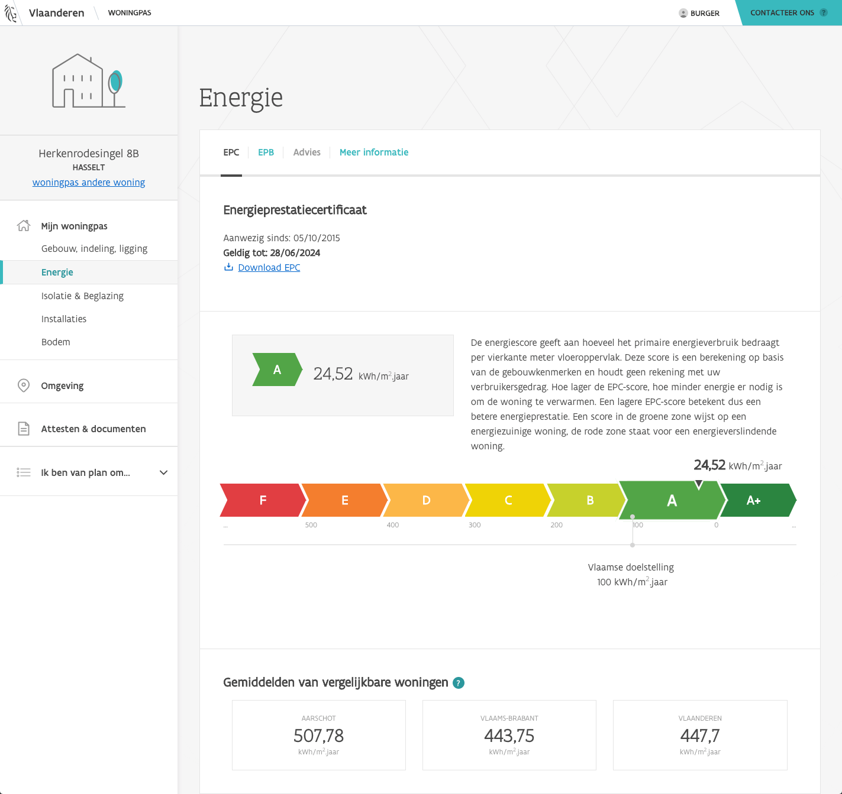

Figure 2 Woningpas energy page[1]

## Individual renovation schedule (iSFP - Individueller Sanierungfahrplan)

The iSFP, Figure 3, is the result of the collaboration between the Institute for Energy and Environmental Research (Ifeu), the Passive House Institute and the German Energy Agency (Dena) together with the Federal Office of Economics and Export Control (BAFA). The scope of the BRP is to offer owners an overview of their homes and its potential. The document includes current state of the building, energy consumption, how to best use the building to save energy, steps to follow for any future renovation, a graphical representation of the measures to be take in the renovation including costs, grants and the energy efficiency obtained after the process is finalized. The iSFP is a result between a dialogue that a certified energy auditor from Germany has with the owner of building, communication that takes place on site. The entire process of creating an iSFP is detailed in the Energy auditor Handbook. The difference from the Woningpas in Flanders is that the iSFP is a printed document and not a digital one.

Figure 3 iSFP Individual renovation schedule[2]

## Energy efficiency passport (Passeport efficacité énergétique –P2E)

The Energy efficient passport – P2E was developed because of the Shift project, done in France by a cluster of private and public companies. The energy efficiency passport is in a digital format, and it is not an energy audit but rather an energy assessment of the building done using a specific guideline developed during the project. The passports are shared between public authorities, homeowners and professionals. The final report highlights all the steps that need to be taken by an individual to perform a renovation project.

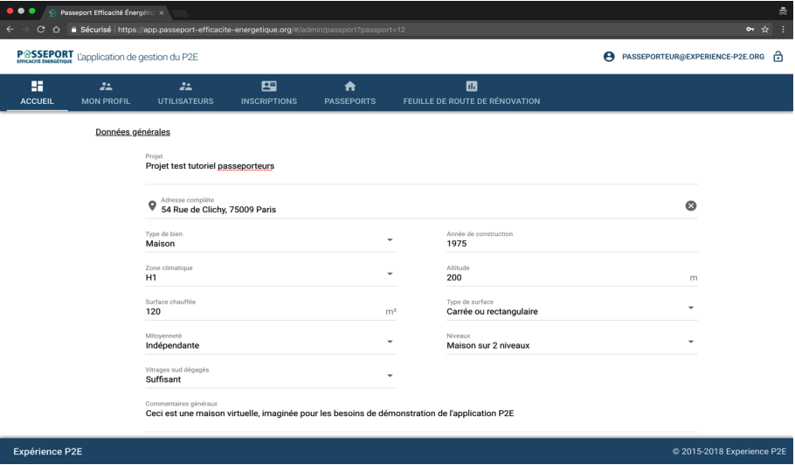

Figure 4 Energy efficiency passport (Passeport efficacité énergétique –P2E) Dashboard

## BIM SPEED BIM Passport

One conclusion that can be drawn from the previously mentioned building passports proposals is that the majority focus only on the energy efficiency of the building and how to maintain and operate it. Most of them represent a collection of physical pr digital documents, but there is no grantee, if the information given there is of high relevance, and if it can be used solely to perform BIM Use Cases in a renovation project. As it was shown in the deliverables from Work Package 1 of the BIM Speed project, the amount of data and the format of the data available is relatively high.

The need to have a document or a tool that can present, simply and concisely, what information is available and what is missing is of upmost need in relate to residential renovation projects. The process to assess the data should also adhere to those two criteria: simplicity and clarity, for the building owners to be interested in making such evaluation. Keeping the document and process simple will incentivize building owners to demand such documents because it will bring value in terms of cost and time reduction.

Considering these aspects, the BIM Passport was created. Its scope is to report the percentage of completeness for the as-built data related to a building. The BIM Passport will have a timestamp to ensure the actuality, and it will be used to ensure that the information reviewed by the assessor has a certain degree of usage in the renovation process, according to the BIM Speed methodology.

BIM Passport integrates with the entire BIM Speed methodology and indicates to the building owner if the process of gathering data has followed the recommendations expressed in Work Package 1, “Collecting and understanding BIM data of existing buildings”. Also, the BIM Passport will notify the owner if a geometrical BIM Model was created considering the guidelines expressed in deliverable 2.4, “Guidelines for as-built BIM modelling of existing buildings”, the deliverable 2.2 “BIM Family ontologies for materials, components, HVAC equipment in renovation” and if it followed the recommendations from BEP used in deliverable 7.6, “ BIM Execution Plan for residential deep renovation”. In addition, the quality of the model should be checked using the criteria and methods depicted in deliverable 5.3, “Methods and tools for rule-based model checking and data validation”. All of the process where a BIM Passport has an impact are shown in Figure 4.

Figure 5 Connection between BIM Passport and other Work Packages

# BIM SPEED Passport

## Purpose of the report

The purpose of this report is to document the process and results of creating a Building passport for the project BIM SPEED. The report will detail the evaluations of maturity, BIM guidelines, and ontologies that were conducted to assess the completeness of the building passport. The report will also present graphical visualizations and certifications of the building passport's completeness. Our approach for creating the BIM Passport has been done in two steps, version 1.0 and version 2.0. In version 1.0, we developed an online tool that used a questionnaire to evaluate an organization's adherence to BIM modeling guidelines. However, this approach had some drawbacks as it was found to be too generic and not useful for stakeholders. In response, we developed version 2.0, which is an excel sheet with multiple evaluations that are more detailed in relation to Deliverables D2.1 “Method and online tool for defining the feasibility”, D2.2 “BIM Family ontologies for materials, components, HVAC equipment”, and D2.4 “Guidelines for as-built BIM modelling of existing buildings”. This version includes more comprehensive evaluations of an organization's BIM maturity and BIM Modeling guidelines. Furthermore, it includes Life Cycle Assessment & Life Cycle Costing Ontology, BEM Reno (Energy KPI & Sustainability KPI) and Reno-Inst Ontology. This improved approach provides more actionable recommendations and allows for a more detailed analysis of an organization's BIM practices, and helps to identify areas for improvement.

## Overview of the deliverable BIM Passport

The deliverable BIM Passport is an electronic document that contains all the relevant information about a building, including design, construction, operation, and maintenance. The BIM passport is created using BIM spreadsheet and is stored in a digital format. It will be based on the results of 3 evaluations: Maturity, BIM guidelines, & Ontologies. The BIM passport can be accessed and updated by all project stakeholders throughout the building's lifecycle, providing an easy-to-use and comprehensive document to manage the building's maintenance and operations, as well as for planning and executing future renovations or retrofits. The evaluation results, including graphical visualization and certification, will be included in the BIM passport to show its completeness.

## BIM Passport Prototype v1.0

The BIM Passport is a tool designed to evaluate the compliance of Building Information Modeling (BIM) projects with established guidelines. A prototype of the BIM Passport was created using a multiple categories questionnaire, and implemented as a website where users could log in, create a new passport, and answer questions related to BIM modelling guidelines. The dashboard displayed basic information about the passport, such as location, creation date, and passport name, as well as a quantitative and qualitative evaluation of the categories.

32 BIM Passports were collected and analysed. After some time, the users of the prototype were contacted to gather feedback on their experience with the tool. Users reported that the BIM Passport prototype was too generic and not useful for stakeholders. They expressed that the tool did not provide enough specific information to be valuable in their decision-making process.

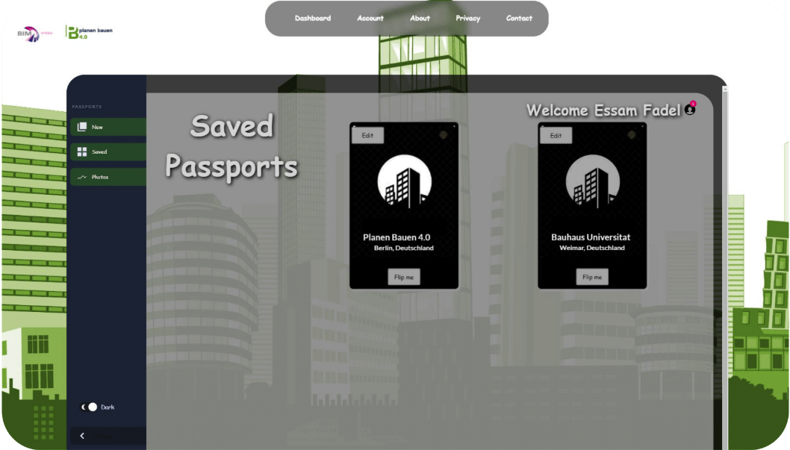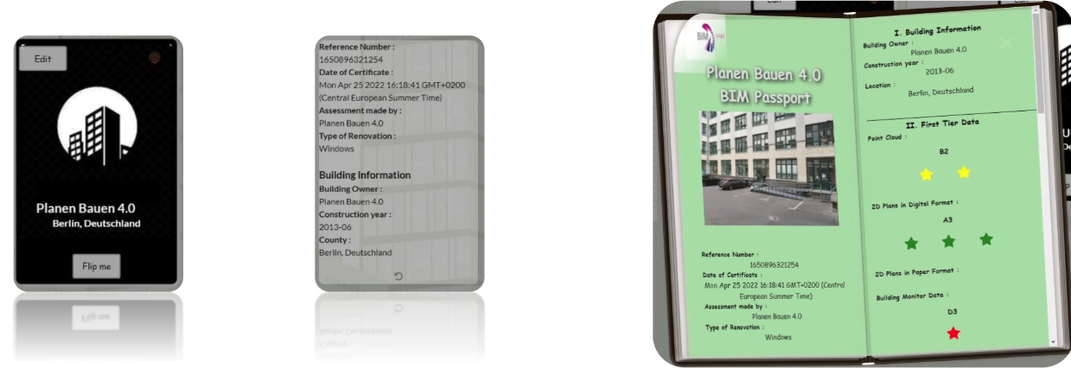Based on the feedback received, a new version of the BIM SPEED - BIM Passport v2.0 was created with the aim of addressing the issues identified by users. The new version is expected to be more specific and useful for stakeholders. The prototype version of the BIM Passport proved to be a valuable learning experience, providing valuable insights on the needs and expectations of users. Further testing and user feedback will be necessary to determine the effectiveness of the new version.

Figure 6 BIM SPEED - BIM Passport v1.0 Dashboard

Figure 7 BIM SPEED - BIM Passport v1.0 Cover Page State, Back Page State, & Full Passport State

## Description of the BIM SPEED – BIM Passport v2.0

The Building Passport is a comprehensive and holistic document that is created as a deliverable of BIM SPEED project. This chapter will contain all the relevant information about the building, including detailed data on the building's design, construction, operation, and maintenance. The building passport will provide the following information:

* Detailed architectural and structural information, including building components and systems
* Information on the building's energy performance and sustainability features
* Information on the building's mechanical, electrical, plumbing and fire protection systems
* Information on the building's compliance with relevant codes, standards and regulations
* Information on the building's maintenance history and schedules

The building passport will be generated using BIM spreadsheet, allowing for seamless integration of data from various sources and stakeholders, providing an accurate and up-to-date representation of the building. The building passport will also be in digital format, allowing for easy access and updates by all project stakeholders throughout the building's lifecycle. It will be completed with the results of the three evaluations, maturity, BIM guidelines, and ontologies to provide a complete, transparent and easy to understand document for managing the building's maintenance and operations, as well as for planning and executing future renovations or retrofits.

It is designed in a user-friendly format and will be easily understood by all stakeholders involved including, architects, engineers, facility managers, builders and building owners. The Building passport will be a valuable tool that will help building owners, managers, and other stakeholders to make informed decisions and improve building performance throughout its lifecycle.

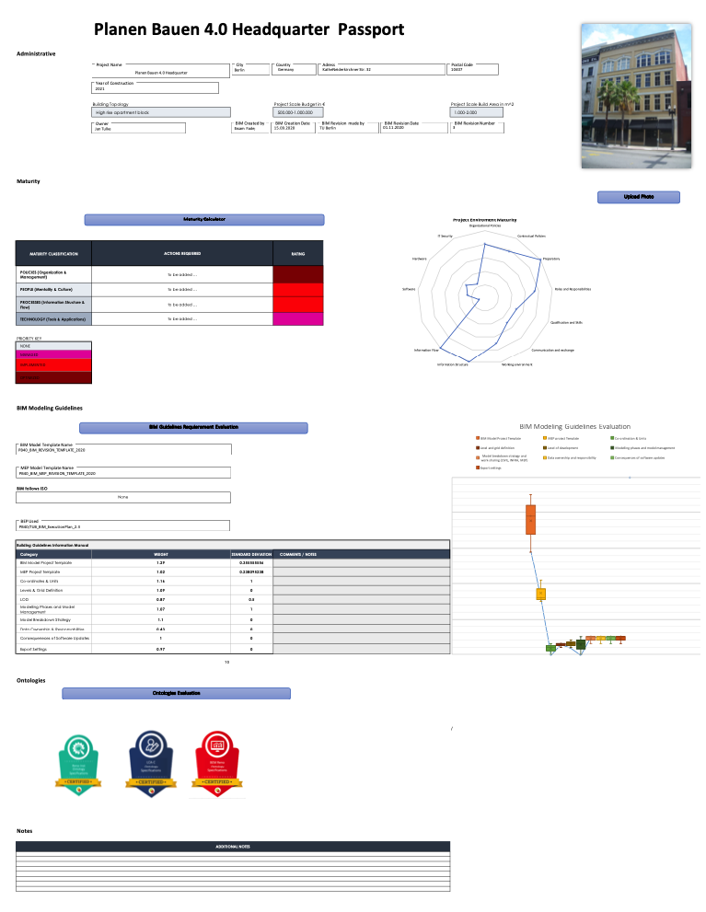

Figure 8 BIM SPEED - BIM Passport v2.0 Main Page

# Maturity Evaluation

## Description of the maturity evaluation process

The maturity evaluation is a process used to assess the level of maturity of the building passport creation process. The evaluation consists of four categories: policies, people, processes, and technology. Each category is evaluated based on a set of criteria and a score is assigned for each criterion. The scores are then used to determine the overall maturity level of the building passport creation process.

### Policies

The policies category evaluates the organization's policies and procedures related to the building passport creation process. The criteria used to evaluate the policies category include:

* The existence of a building passport policy
* The level of management support for the building passport process
* The level of employee awareness of the building passport process
* The level of compliance with relevant regulations and standards

### People

The people category evaluates the organization's human resources related to the building passport creation process. The criteria used to evaluate the people category include:

* The availability of skilled personnel for the building passport process
* The level of employee training and development related to the building passport process
* The level of employee engagement in the building passport process
* The level of employee accountability for the building passport process

### Processes

The processes category evaluates the organization's processes and procedures related to the building passport creation process. The criteria used to evaluate the processes category include:

* The level of integration between the building passport process and other organization processes
* The level of automation of the building passport process
* The level of quality control and quality assurance in the building passport process
* The level of data management and data security in the building passport process

### Technology

The technology category evaluates the organization's technology infrastructure related to the building passport creation process. The criteria used to evaluate the technology category include:

* The level of BIM software usage
* The level of data interoperability in the building passport process
* The level of data analytics capabilities
* The level of cybersecurity in the building passport process

## Results of the maturity evaluation

Based on the evaluation results, a score will be given for each category, as well as an overall score. These scores will be used to determine the overall maturity level of the building passport creation process. The maturity level will be represented with graphical visualization. The overall score of the maturity evaluation is calculated by assigning a weight to each question and a score to each answer within the questions. The weight reflects the importance of the question in the overall evaluation and the score reflects the level of maturity of the organization in relation to that question. The scores from all of the questions in each category are then added up and divided by the total weight of the questions in that category. This results in a score for each category, which represents the overall maturity level of the organization in that category.

All categories are then presented in a spider chart, which allows for a visual representation of the organization's level of maturity in each category. The spider chart shows the scores for each category on a scale of 0 to 5, with 0 indicating a low level of maturity and 5 indicating a high level of maturity. This allows for an easy comparison of the organization's level of maturity in each category and helps to identify areas where the organization needs to improve.

## BIM Maturity Questionnaire

The questions that were provided can be grouped into several categories that assess different aspects of an organization's maturity, implementation and use of Building Information Modeling (BIM) technology:

1. Standards and Guidelines: The questions related to open standards and the organization's own BIM standards aim to understand whether the organization is following industry-wide best practices and guidelines in their BIM implementation.
2. Planning and Strategy: These questions are related to the organization's overall BIM implementation plan and strategy, including the availability of a BIM implementation plan on an enterprise level, and the organization's goals for implementing BIM.
3. Communication and Training: Questions related to the communication channels and the availability of training for staff aim to understand whether the organization is providing the necessary resources for staff to understand and work with BIM technology.
4. Data Management and Quality Control: These questions are related to the organization's management of data and the procedures in place to ensure the quality of the data, including data security and property rights, as well as the information flows between the organization and its partners.
5. BIM Processes and Workflows: The questions in this category are related to the organization's specific processes and workflows for working with BIM models, including the involvement of different departments, such as OHS, Purchasing, Financial and Quality Control, and the use of specific BIM tools and software.
6. BIM Maturity and Adoption: These questions aim to understand the organization's level of BIM maturity and the challenges they face in achieving large scale adoption of BIM technology, as well as the organization's readiness to use BIM in short term.
7. Level of detail (LOD) and Level of Information (LOI): These questions aimed to understand the organization's understanding of the level of detail and level of information required at each project phase.

Overall, the questions aim to provide a comprehensive understanding of an organization's current use and implementation of BIM technology and identify areas for improvement.

## Maturity Future Recommendations

The BIM Maturity Evaluation is a process used to assess an organization's current level of maturity in the use of Building Information Modelling (BIM). The evaluation is based on four main categories: policies, people, processes, and technology. The results of the evaluation are presented as a rating, with levels ranging from "None" to "Optimized". Based on these results, recommendations are provided to help the organization improve its level of maturity in each category.

Policies

In the category of policies, the recommendations focus on the use of open standards, such as .ifc files, for exchanging information between stakeholders. Additionally, it is recommended that the organization creates a BIM template for projects, implement a BIM implementation plan, and adopt a national or international BIM standard. Other recommendations in this category include creating guidelines for understanding BIM terminology, establishing quality data checks, and defining roles and responsibilities within a BIM project.

People

In the category of people, the recommendations focus on establishing clear roles and responsibilities within the organization, as well as providing training for new BIM tools. Additionally, it is recommended that the organization establish a communication channel for colleagues to share feedback.

Processes

In the category of processes, the recommendations focus on defining a workflow for data information, as well as establishing BIM quality processes and work instructions for standard tasks. Additionally, it is recommended that the organization define the level of information that it delivered and create a list of requirements for each level of information.

Technology

In the category of technology, the recommendations focus on ensuring interoperability with open BIM standards, ensuring proper hardware, and creating a back-up data plan. Additionally, it is recommended that the organization select appropriate BIM software and set up procedures and workflows considering the Common Data Environment (CDE) used.

Overall, the recommendations provided aim to help the organization improve its level of maturity in BIM by focusing on policies, people, processes, and technology. By implementing these recommendations, the organization can expect to increase the efficiency and quality of its BIM projects.

## Graphical visualization of the maturity level

The graphical visualization of the maturity level will be represented using a spider chart (also known as radar chart) that shows the scores for each category and the overall score on the same graph. The spider chart will have four axes, one for each category, policies, people, process, and technology. The spider chart will be divided into different sections, each section will represent the scores for each criterion within the category.

The spider chart will provide a clear visual representation of the strengths and weaknesses of the building passport creation process. It will also allow stakeholders to easily compare the scores of each category and identify areas where improvement is needed. By using a spider chart, stakeholders will be able to see how well the building passport process is performing in each category and how those categories compare to each other briefly. In addition to the spider chart, the report will also include a summary table that shows the scores for each category, future recommendations, and the overall score. This table will provide detailed information on the scores for each criterion and will allow stakeholders to dig deeper into the results of the maturity evaluation.

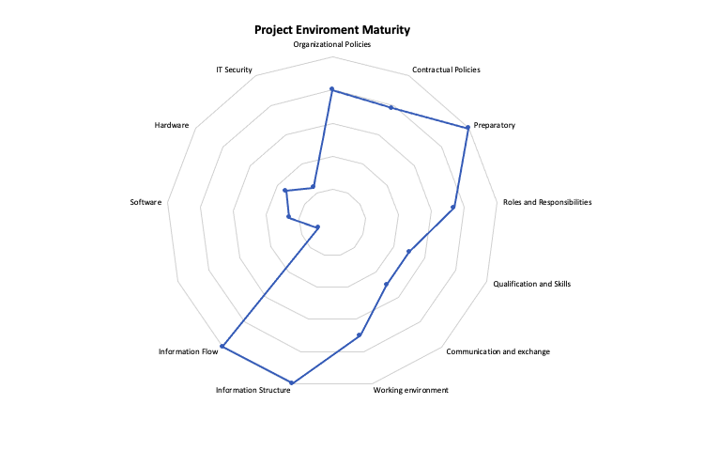

Figure 9 Maturity Tool Evaluation Result (Spider-Chart)

# BIM Guidelines Evaluation

## Description of the BIM guidelines evaluation process

The BIM Guidelines evaluation is a process used to assess the level of compliance of the building passport with relevant BIM guidelines and standards. The evaluation process involves an assessment of the building passport against a set of BIM guidelines and standard; developed in deliverable 2.4, “Guidelines for as-built BIM modelling of existing buildings”. The assessment is based on a set of criteria and a score is assigned for each criterion. The scores are then used to determine the overall compliance level of the building passport with BIM guidelines and standards.

The criteria used for the BIM Guidelines evaluation include:

* Information completeness, level of information embedded in the model
* Level of collaboration and coordination among project stakeholders
* Level of conformity with BIM Execution Plan (BEP)
* Level of conformity with relevant industry standards and regulations
* Level of automation and use of BIM technology

## Results of the BIM guidelines evaluation

The evaluation results will be presented in a Box and Whiskers diagram, it will show the user's score compared to the allowable threshold for each criterion. The box and whiskers diagram provides a clear visual representation of the distribution of scores and allows for easy comparison between the user's scores and the allowable threshold.

Additionally, a table will be included that shows the weight and standard deviation of each criterion. The weight will indicate the importance of each criterion in the overall compliance level, while the standard deviation will show how much the scores for each criterion deviate from the mean. A standard deviation close to 0 indicates that the scores for the criterion are consistent and no further action is required, while a higher standard deviation indicates that the scores are more spread out and further action may be required to improve the criterion.

The table and diagram will show the following details for each criterion:

* Name of the criterion
* Score assigned by user’s input
* Allowable threshold for the criterion
* Weight for the criterion
* Standard deviation for the criterion

## BIM Modeling Guidelines Questionnaire

The questions provided relate to the use of a Building Information Modeling (BIM) project template and its adherence to industry standards and guidelines. The categories these questions can be grouped into include:

1. Template Availability and Creation: The questions related to the availability of a BIM project template and who created it aim to understand whether the organization has a standardized starting point for their BIM projects.
2. Template Content and Settings: These questions focus on the contents and settings within the BIM project template, including the presence of settings in all views, as well as settings that are expressed in the Model View Definition (MVD).
3. MVD and Design Guidelines: The questions related to the MVD and the inclusion of a guide for designers aim to understand whether the template is providing clear and consistent guidelines for the project team to follow.
4. Distinctive Elements for Renovation Projects: This question aims to understand whether the template includes any specific elements that are unique to renovation projects.
5. Naming Convention: This question aims to understand whether the template follows a consistent naming convention for the BIM elements.
6. MEP Template Content: These questions focus on the contents and settings within the MEP template, including the type of piping, ducts, and electrical systems used, as well as the colors and specifications assigned to the MEP elements.
7. BIM Execution Plan (BEP): These questions aim to understand whether the BIM project template includes a BEP that defines the coordination and units used, as well as the level and grid definition in the model.
8. ISO 19650-1 Scope: These questions aim to understand whether the level of geometry and information in the BIM project template follows the ISO 19650-1 scope.
9. Renovation Projects Phases: This question aims to understand whether the template includes the three phases of renovation projects: existing, demolition, and new phase and whether these phases are clearly identified in the BIM model.
10. Model Breakdown and Data Ownership: These questions aim to understand whether the BIM model includes multiple breakdowns and whether the data ownership and responsibility matrix is clearly defined in the BEP.
11. Backup and Export Settings: These questions aim to understand whether the organization has a backup plan in place for the entire BIM project, and whether the export settings follow the guidelines of ISO 29481-1:2016.

Overall, these questions aim to assess the organization's use of a BIM project template and its adherence to industry standards and guidelines, as well as the level of detail and information included in the template to ensure the quality of the project

## Graphical visualization of the BIM guidelines compliance

The results of the BIM guidelines evaluation will be represented graphically using a box and whiskers diagram. The diagram will show the distribution of scores for each criterion and the allowable threshold for each criterion. The box and whiskers diagram provides a clear visual representation of the distribution of scores and allows for easy comparison between the user's scores and the allowable threshold.

Additionally, the user's score for each criterion will be presented as a line diagram, which will be overlaid on the box and whiskers diagram. This line diagram will provide a clear representation of the user's score for each criterion and how it compares to the allowable threshold. If the line diagram is within a certain threshold (specified by the project's BIM standard), that criterion is deemed sufficient. The diagram will provide a clear visual representation of the compliance level for each criterion and will allow stakeholders to easily identify areas where improvement is needed.

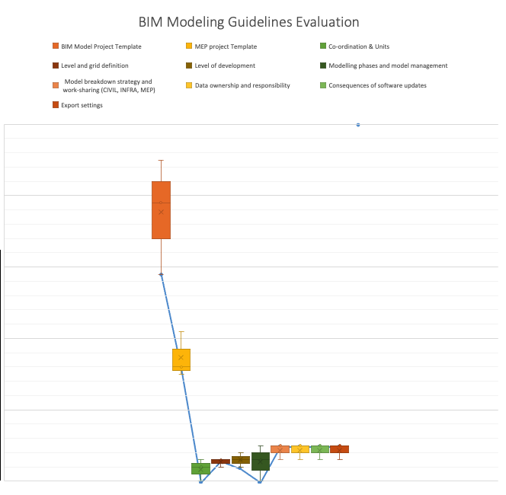

Figure 10 BIM Modeling Guidelines Evaluations Result (Box & Whiskers Diagram - overlapped with Line Diagram)

# Ontologies Evaluation

## Description of the ontology’s evaluation process

The ontologies evaluation is a process used to assess the building's compliance with relevant ontologies specifications. The evaluation process involves an assessment of the building based on three categories: Reno-Inst, LCA-C and BEM-Reno. The assessment is based on a set of questions and requires user input. The input represents the state of the building according to the ontology’s specifications. The evaluation will be simple and easy to understand, with straightforward questions that are easy to answer.

### Reno-Inst

The Reno-Inst category evaluates the building's renovation and installation state according to the Reno-Inst ontologies specifications. The questions used to evaluate the Reno-Inst category include:

* The type of renovations or installations that have been carried out in the building
* The materials used in the renovations or installations
* The energy efficiency of the renovations or installations

### LCA-C

The LCA-C category evaluates the building's life-cycle assessment and cost state according to the LCA-C ontologies specifications. The questions used to evaluate the LCA-C category include:

* The energy efficiency of the building
* The carbon emissions of the building
* The lifecycle assessment of the building

### BEM-Reno

The BEM-Reno category evaluates the building's energy management and renovation state according to the BEM-Reno ontologies specifications. The questions used to evaluate the BEM-Reno category include:

* The energy management systems in place in the building
* The energy efficiency of the building
* The type of renovations or retrofits that have been carried out to improve the building's energy efficiency

## Results of the ontologies evaluation

Based on the user's input, a score will be given for each category, as well as an overall score. These scores will be used to determine the overall compliance level of the building with relevant ontologies specifications. If the scores for all categories meet or exceed a certain threshold, a certificate will be presented in the building passport main page to show that this building is compliant with the ontology’s specifications.

## Ontologies Questionnaire

### Reno-Inst Ontology

The questions provided relate to the use of a Building Information Modeling (BIM) ontology for renovation projects. The ontology is a set of concepts and relationships used to describe the building elements and their properties. The categories these questions can be grouped into include:

1. Building Elements: The questions related to building elements represent external and internal elements of the building, such as the roof, façade, walls, floors, and ceilings. The state interface for each element is described.
2. Interfaces: The questions related to interfaces aim to understand whether the building elements are described by an interface that includes material, dimensions, and other physical attributes. The building elements are also linked to constructive or system interfaces.
3. Constructive Interface: The questions related to the constructive interface aim to understand whether the interface is defined by units, area, openings, and points.
4. System Interface: The questions related to the system interface aim to understand whether the interface is defined by units, pipes, and valves.
5. Building Elements Location: The question related to the location of building elements aim to understand whether all building elements have a location identified.
6. Building Elements Components: The question related to the building elements components aim to understand whether the building elements contain either functional or interface components.
7. Building Model Documentation: The questions related to the building model documentation aim to understand whether the documentation includes drawings, manufacture instructions, standards, and survey sheets. The documentation also includes information such as author, cost, description, duration, ID, installation position, manufacturer, names, qualities, types, and units.

Overall, these questions aim to assess the organization's use of a BIM ontology for renovation projects, and the level of detail and information included in the ontology to ensure the quality of the project. The ontology aims to create a consistent and standardized way of describing the building elements and their properties, which allows for better interoperability and communication between different stakeholders.

### LCA/C Ontology

The questions provided relate to the use of a Life Cycle Assessment (LCA) and Life Cycle Costing (LCC) ontology for building projects. The ontology is a set of concepts and relationships used to describe the building data and its properties, as well as the building's life cycle stages and associated costs. The categories these questions can be grouped into include:

1. BIM Data Property: The questions related to BIM data property aim to understand the contents of the BIM model, including its description, name, quantities, reference service life, units, values, and year of replacement.
2. Building Life Cycle Stages: The questions related to the building life cycle stages aim to understand the different stages of the building's life cycle, including product stage, construction stage, use stage, and end of life stage. The questions also relate to the boundary scenarios for each stage.
3. Building Cost Indicator: The questions related to the building cost indicator aim to understand the different types of costs associated with the building, including construction cost, acquisition cost, installation cost, transport cost, end of life cost, cost at disposal, end of life residual valuation, global cost, annual cost, internal rate of return, investments cost, net savings, payback period, savings to investment ratio, maintenance cost, cleaning and minor repairs, indirect cost of maintenance, maintenance activities, and maintenance management activities.
4. Building Cost Parameter Type: The questions related to building cost parameter type aim to understand the different types of costs associated with the building, including construction cost, acquisition cost, installation cost, transport cost, end of life cost, cost at disposal, end of life residual valuation.
5. Environmental Indicators: The questions related to environmental indicators aim to understand the assessment building general information, area, building type, required service life, technical requirements, initial building lifetime, year of commissioning, year of previous refurbishment, standard or guidelines used, building materials and renovation products.

Overall, these questions aim to assess the organization's use of a LCA and LCC ontology for building projects, and the level of detail and information included in the ontology to ensure the quality of the project. The ontology aims to create a consistent and standardized way of describing the building's life cycle stages, associated costs, and environmental indicators

### BEM-Reno Ontology

Energy KPIs

The questions provided relate to the use of a Building Energy Model (BEM) for renovation projects, specifically focusing on key performance indicators (KPIs) related to energy consumption and generation. The categories these questions can be grouped into include:

1. Energy Consumption: The questions related to energy consumption aim to understand the total primary energy consumption, primary energy non-renewable total (PENRT), electric energy consumption, natural gas energy consumption, district heating energy consumption, and other fuel types used.
2. Heating and Cooling Loads: The questions related to heating and cooling loads aim to understand the peak heating load and heating load profile, peak cooling load and cooling load profile, heating and cooling energy demand, and peak electricity load and electricity load profile.
3. Energy Generation: The questions related to energy generation aim to understand the PV electric energy generation and solar thermal energy generation.
4. Impact Indicators: The questions related to impact indicators aim to understand the annual energy savings, energy savings (percentage), reduction of peak energy load (percentage), and GHG emissions reduction (percentage).

Overall, these questions aim to assess the organization's use of a BEM for renovation projects, and the level of detail and information included in the BEM to ensure the quality of the project. The BEM aims to create a consistent and standardized way of describing the building's energy consumption and generation, as well as the associated impact indicators.

Sustainability KPIs

The questions provided relate to the use of a Building Energy Model (BEM) for renovation projects, specifically focusing on key performance indicators (KPIs) related to sustainability. The categories these questions can be grouped into include:

1. Environmental Impact: The questions related to environmental impact aim to understand the building's impact on global warming potential, water pollution, and air pollution.
2. Environmental Cost Indicator: The question related to environmental cost indicator aims to understand the environmental cost associated with the building.
3. Impact Indicator: The questions related to impact indicator aim to understand the return on investment (ROI), payback period, increase in rental rate of building, and increase of resale rate of building.

Overall, these questions aim to assess the organization's use of a BEM for renovation projects, and the level of detail and information included in the BEM to ensure the quality of the project. The BEM aims to create a consistent and standardized way of describing the building's environmental impact and cost, as well as the associated impact indicators

## Certification visualization of the ontologies compliance

Based on the evaluation scores and user's input, a certificate will be presented in the building passport main page. The certificate is in the form of a logo indicating that the building is compliant with the relevant ontologies’ specifications and the deliverables criteria of the BIM SPEED Project. This logo will be added to the passport if the scores for all categories meet or exceed a certain threshold set by the project's BIM standard. This certificate serves as a visual representation of the building's compliance with the ontologies and demonstrates that the building has been evaluated and found to meet the deliverables criteria presented in the different deliverable reports.



Figure 11 Ontologies Evaluation Result as Certificates

# Building Passport Summary

## Summary of all the evaluation results

The Building Passport report includes evaluations of the building's maturity, compliance with BIM guidelines and standards, and compliance with relevant ontologies specifications. The evaluations were based on a set of criteria and scores were assigned for each criterion. The scores were then used to determine the overall maturity level, compliance level, and compliance with relevant ontologies specifications of the building passport.

To provide a clear and easy-to-understand representation of the evaluation results, graphical visualizations were included in the report. The visualizations include spider charts, box and whiskers diagrams, and line diagrams. These diagrams provide a clear representation of the scores for each criterion and allow stakeholders to easily compare the scores and identify areas where improvement is needed.

Based on the evaluation scores, certifications were issued for the building passport. These certifications provide assurance of the building passport's quality and compliance with relevant standards and regulations. The certifications include the overall score and scores for each criterion and are provided in a digital form, that can be accessed and verified by relevant authorities and stakeholders.

# Conclusion

## Summary of the report

The BIM Passport is a comprehensive and holistic document that is created as a deliverable of the BIM SPEED project. The document contains all the relevant information about the building, including detailed data on the building's design, construction, operation, and maintenance.

The building passport was created through the application of three evaluations: maturity, BIM guidelines, and ontologies. The maturity evaluation provided insight into the building passport creation process and identified areas for improvement. The BIM guidelines evaluation ensured that the building passport conforms to relevant BIM guidelines and standards. The ontologies evaluation assessed the building's compliance with relevant ontologies specifications.

The results of these evaluations were presented in an easy-to-understand format, using graphical visualizations and certifications. The graphical visualizations provided a clear representation of the building passport's compliance with the evaluation criteria and allowed stakeholders to easily identify areas where improvement is needed. The certification provided assurance of the building passport's quality and compliance to relevant authorities and stakeholders.

The building passport will be a valuable tool for building owners, managers, and other stakeholders to make informed decisions and improve building performance throughout its lifecycle. It will also serve as a record of the building's history, which will be useful for future renovations or retrofits. The BIM SPEED project team has provided a comprehensive deliverable that can be used as a guide in managing the building's maintenance and operations, as well as for planning and executing future renovations or retrofits.

## Recommendations for future improvements

The deliverable BIM Passport report presented a detailed evaluation of the building passport and the building it represents. The report covered three main evaluations: maturity, BIM guidelines, and ontologies. Each evaluation was based on a set of criteria and scores were assigned for each criterion. The scores were then used to determine the overall maturity level, compliance level, and compliance with relevant ontologies specifications of the building passport. The report also included graphical visualizations and certifications to provide a clear and transparent representation of the evaluation results.

The evaluations revealed areas of strengths as well as areas for improvement for the building passport and the building it represents. Based on the results, recommendations for future improvements were provided to address any deficiencies identified in the evaluations. These recommendations include implementing automated processes, updating the building passport to meet industry standards, and improving the building's energy efficiency. The report also provided a detailed action plan for implementing the recommendations.

The BIM Passport is an important tool for building owners, managers, and other stakeholders. It provides a comprehensive understanding of the building and its processes, as well as a clear and transparent representation of its compliance with relevant standards and regulations. The BIM Passport has a wide range of potential applications and its development is still ongoing. It is expected to be continuously updated, improved.

In order to further improve the effectiveness of the BIM Passport, we suggest exploring the implementation of measures for assessing the quality of available BIM data. While the current approach primarily focuses on determining the existence and consistency of data within the BIM model, it is important to also consider the accuracy and completeness of this data.

One potential approach for measuring the quality of BIM data is through the use of automated processes. These processes can be designed to check for specific data elements and ensure that they adhere to certain standards and guidelines. For example, automated checks can be implemented to verify that certain data fields, such as material properties or component dimensions, are accurately represented within the BIM model.

Another potential approach is to establish a checking system, in which a designated individual or team is responsible for reviewing and verifying the quality of BIM data. This can include manual checks for data accuracy and completeness, as well as reviews of the BIM model to ensure that it adheres to established standards and guidelines.

Incorporating these types of measures for assessing the quality of BIM data can greatly enhance the effectiveness of the BIM Passport by providing a more comprehensive evaluation of the data included within the BIM model. This can lead to more accurate and reliable results, and ultimately, better-informed decision-making for building projects.

# References

## List of sources used in the report

Comission, E. E. (n.d.). *Building stock characteristics*. Retrieved from EU European Commission: https://ec.europa.eu/energy/eu-buildings-factsheets_en

European Parliament . (2010). Directive 2010/31/EU. *Directive 2010/31/EU of the European Parliament and of the council of 19 May 2010 on the energy performance of buildings.* .

European Parliament. (2018, may 30). Directive (EU) 2018/844. *Directive (EU) 2018/844 amending Directive 2010/31/EU on the energy performance of buildings and Directive 2012/27/EU*. European Parliament.

*Evolution of households energy consumption patterns across the EU*. (2021, December 16). Retrieved from Enerdata: https://www.enerdata.net/publications/executive-briefing/households-energy-efficiency.html

Flemish Energy and Climate Agency. (n.d.). *Woningpas*. Retrieved from Woningpas: https://woningpas.vlaanderen.be/web/guest/

Marta Maria Sesana, G. S. (2018). A review on Building Renovation Passport: Potentialities and barriers on current initiatives. *Energy & Buildings*, 195-205.

Project, T. S. (n.d.). *Energy Efficiency passport (P2E)*. Retrieved from The Shift project: https://theshiftproject.org/experience-p2e/

# Appendices

## Any additional material relevant to the report such as questionnaires, data and screenshots

Maturity Questionnaire

Appendix 2:

* Does your organization use open standards to communicate with external partners ?
* Does your organitazion have general BIM standards ?
* Is there any BIM Implementation-Plan or a general strategy on enterprise level availbale?
* Are there channels to communicate and understand the BIM vision by staff?
* Do you have BIM Process-Manuals to introduce BIM on development-level
* Are there quality controls in place for data?
* Are data security and property rights defined in contractural documents?
* Are the information flows between your organization and your (project) partners described/written down?
* Availability of statements defining the responsability of each stakeholder regarding information management
* Does you organization provide for structured external training of staff?
* Does you organization provide for structured internal training of staff?
* Are role descriptions clearly and decisively defined and fixed within your organization?
* Are the BIM roles clearly defined in your organization?
* Are the team structures/dynamics consistent or performance is only depending on the employees "heroism"?
* Is there someone within your organization who is the final responsible for effective and efficient work with BIM?
* Are there staff training sessions related to BIM tools?
* What expertise/experience does your organization have in working with BIM?
* From 0 (lowest) to 5 (highest), which level of BIM maturity would you consider currently for your organization/company?
* Are there channels or nethods to transfer knowledge between staff members?
* Is there a mechanism to allow feedback from staff members on the information structure and BIM products?
* Is there any strategy to improve the working environment as a factor of productivity?
* Do you have tools to control, manage, and modify the working environments to enhance staff motivation, satisfaction and productivity
* Does your organization define the appropriate level of information needed in each project phase?
* Does your organization define the minimum parametrization level in the model
* Is there a quality checking process in place for importing new data in your dataset?
* Are the information flows within your organization described/written down?
* Are the information flows between your organization and your (project) partners described/written down?
* Do you define process maps for working on BIM models?
* Do you involve OHS department in BIM processes?
* Do you involve Purchasing department in BIM processes?
* Do you involve Financial department in BIM processes?
* Do you involve Quality Control department in BIM processes?
* What is your primary designing workflow?
* How prepared are you to issue your native format files?
* Do you check the quality of BIM Models?
* Do you perform quantity take-offs based on BIM Models?
* Do you carry out clash detection by using BIM Models?
* Do you understand the Level Of Detail (LOD) required at each project phase?
* Do you understand the Level Of Infromation (LOI) required at each project phase?
* From 0 (Totally disagree) to 5 (totally agree) do you agree to have the adecuate software for aimed BIM use cases?
* In which percentage does your organization work with IFC files (Open BIM)?
* From 0 (Totally disagree) to 5 (totally agree) do you agree to have the adecuate software in alignment with the organization goals and strategy?
* Inside your company, in which percentage of working-posts is installed BIM software?
* From 0 (Totally disagree) to 5 (totally agree) do you agree to have the adecuate hardware for aimed BIM use cases?
* From 0 (Totally disagree) to 5 (totally agree) do you agree to have the adecuate hardware in alignment with the organization goals and strategy?
* From 0 (Totally disagree) to 5 (totally agree), does your organization have defined hardware specifications to work with BIM technology?
* How often does your organisation create a data back copy?
* How secure do you consider your organization is in terms data security?
* Are networks solutions for harvesting, storing and sharing knowledge, within and between organizations, well managed through common platforms?
* Does your organization actively use the Collaborative Data Environment (CDE) platform within projects?

BIM Modeling Guidelines Questionnaire

Appendix 2:

* is there a BIM Model Project Template avaialble
* Who Created the Template
* Project template have settings expressed in all Views Project template have settings expressed in MVD
* MVD Refers to
* Project Template includes a guide for designers
* Project Templates have distencive Elements for Renovation Projects
* Follows Naming Convention
* MEP Template Includes
* Type of Piping used is Defined according to
* MEP Elements are assigned different colors and specs
* Type of Ducts used is Defined according to
* Type of Electrical Systems used is Defined according to
* Coordination and Units are defined in the BEP and follows the Commonly Used Units ?
* Level and Grid definition are identified and represented in the model ?
* Level of Geometry follows the ISO 19650-1 Scope ?
* Level of information follow the ISO 19650-1 Scope ?
* Renovation Projects includes 3 Phases (Exisiting, Demolititon, New Phase ) , are they are identified in the BIM Model
* Does the Model Have multiple Break downs ?
* Data Owner ship and Responsability Matrix is idenetified in the BEP ?
* Back up plan is available for the entire BIM Project
* Export Settings follows the guidelines of ISO 29481-1:2016

Reno-Inst Ontologies Questionnaire

Appendix 3:

* Building Model contains Building Elements representing External Elements
* External Elements includes Roof and Façade
* what is the roof elements state interface
* what is the Façade elements state interface
* Building Model contains Building Elements representing Inner Elements
* Inner Elements includes Walls, Floor & Ceiling
* what is the walls elements state interface
* what is the floors elements state interface
* what is the ceiling elements state interface
* All Building Elements is described by an Interface
* Interfaces has Material, Dimensions & Other phyiscal attributes described
* All Building Elements is linked to Constructive or System Interface
* Constructive Interface is defined by
* System Interface is defined by
* All Building Elements has location identified
* Building Elements contains either Functional or Interface Components
* Building Model contains Documentation including Drawings, Manufacture Instruction, Standards & Survey Sheet
* Documentation includes: Author Cost Description Duration ID Installation Position Manufacturer Names Qualities Types Units

LCA/C Ontologies Questionnaire

Appendix 4:

* BIM Data Property contains : BIM Model, description, Name, Quantaties, Reference Service Life, Units, Values, Year of Replacement
* Building life cycle stage
* Building life cycle stage
* Boundry Scenario is a
* Building Cost Indicator is type of : Acquisition Cost, Installation Cost, Transport Cost, Cost at Disposal, End of Life Residual Valuation, Annual Cost, Internal Rate of Return, Investments Cost, Net Savings, Payback Period, Savings to Investment Ration, Cleaning and Minor Repairs, Indirect cost of Maintainance, Maintainance Activities, Maintainance Management Activities
* Building Cost Parameter Type : Acquisition Cost, Installation Cost, Transport Cost, Cost at Disposal, End of Life Residual Valuation
* Enviromental Indicators is type off
* Assessment Building General Information: Area, Building Type, Requiered Service Life, Technical Requierments, Intial Building Lifetime, Year of Commissioning, Year of Previous Refurbishment
* Standard or Guidelines Used
* Building includes Materials and Renovation Products : Materials used, Renovation Products includes

BEM-Reno Ontologies Questionnaire

Appendix 5:

* Total primary energy consumption
* PENRT Primary energy nonrenewable
* total Electric energy consumption
* Natural gas energy consumption
* District heating energy consumption
* Other fuel types
* Peak heating load and heating load profile
* Peak cooling load and cooling load profile
* Heating and cooling energy demand
* Peak electricity load and electricity load profile
* PV electric energy generation
* Solar thermal energy generation
* Annual Energy Savings
* Energy Savings (percentage)
* Reduction of peak energy load (percentage)
* GHG emissions reduction (percentage)
* Global Warming Potential
* Water pollution
* Air pollution
* Environmental Cost Indicator
* Return on Investment (ROI)
* Payback Period
* Increase in rental rate of building
* Increase of resale rate of building

Maturity Spider-Chart

Appendix 6:



BIM Modeling Guidelines Box & Whiskers Diagram overlaped with Line Diagram

Appendix 7:



Ontologies Certifications

Appendix 8:



BIM Passport Main Page

Appendix 9:



1. [De Woningpas - Public welcome page (vlaanderen.be)](https://woningpas.vlaanderen.be/)
2. [individueller Sanierungsfahrplan (ISFP) – MySchornie](https://myschornie.de/index.php/sanierungsfahrplan/)